**\*Curbside – How to Reserve a Book:**

1. Place a hold on a book through the library catalog: Go to the BLMS online library catalog[**here**](http://library.issaquah.wednet.edu:81/cataloging/servlet/presentadvancedsearchredirectorform.do?l2m=Library%20Search&tm=TopLevelCatalog&l2m=Library+Search): https://bit.ly/373lNQ2

2. Click on “**Library Catalog**”: 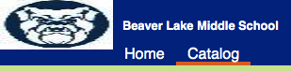

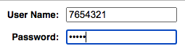3. Click “**Log In**” icon (upper right): 

4. **Log in** with your “User Name” & “Password”:

User Name: **ASB#** (without any preceding zeros)

Password: **your last name**

5. Click on the “**Catalog**” tab: 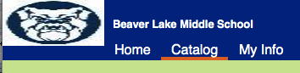

6. **Search** the catalog for the book you want (by subject, title, author…)

Example: search for “fake news” 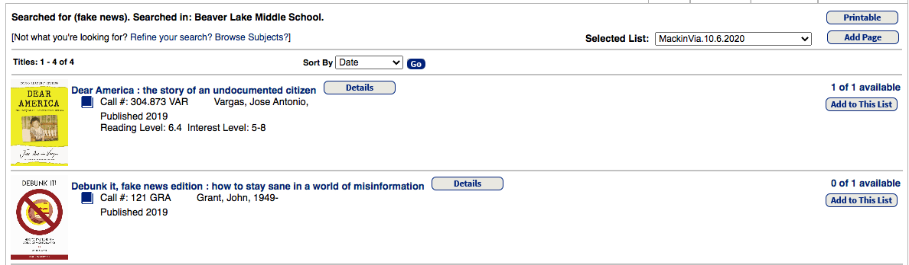

7. Check to see if the book is **available.**

8. Click on **book title** to place a hold.

9. Click on “**Hold it**” 

10. Holds must be placed by **Friday** for pick up on the following day, Wednesday.

11. You will receive a **confirmation email** by Tuesday at 4pm for books ready to be picked up on

Wednesday. This email message will be sent to your “Home email” in Skyward.

**Other check-out notes:**

- If a book is not available you may still put a hold on it. You will be sent a message when it is ready.

- You can check out 5 books at a time and books are due in 3 weeks

- Want to renew your book? Other questions? Email: <mailto:klinek@issaquah.wednet.edu>

**Curbside – Picking Up Books:

1. Book pick-ups will be every Wednesday from _7 a.m._ - _7 p.m__.

2. Books will be available at the main BLMS entrance.

3. Books may be returned at this time on Wednesdays as well.

**SAFETY:**

Park in the north parking lot.

Wear a mask at all times.

Maintain social distancing – be sure to observe the spacing indicators outside the main entrance if there is a line.

Questions? email: <mailto:klinek@issaquah.wednet.edu>